
June 2015
Residential Tenancies Act Review Laying the Groundwork - Consultation Paper

Foreword

We all have a right to safe, affordable and secure housing.
This includes the growing number of Victorians who are renting.
The rental market has changed over time. People are renting for longer, more older people are renting, and the number of property manager and landlords has increased.
That is why the Andrews Labor Government is committed to reviewing the Residential Tenancies Act 1997.
This consultation paper marks the first stage of this review. We would like Victorians to let us know about their experiences of the rental market.
This review will contribute to Victoria’s vision for a modern and dynamic rental market in which tenants are safe and secure, and which meets the current and future needs and expectations of tenants, landlords and their property managers.
It will focus on specific issues identified by the Government, such as the viability of longer-term leasing, as well as protections for people who are older, living with disabilities, and who live in caravan parks and residential parks.
This review is one part of the Government’s broader work program under its Plan for Fairer, Safer Housing to ensure that all Victorians can access safe, affordable and secure housing. This broader program includes investments in services, work on better building regulations, as well as improving the alignment of relevant regulatory requirements under the Building and Public Health and Wellbeing Acts.
The Government’s work program also includes action on housing affordability, planning reform and the work of the Royal Commission into Family Violence, as well as developing a new Integrated Community Care system to holistically support the health and well-being of all Victorians.
All Victorians have the opportunity to have a say about the rental market and I encourage them to share their views by going to fairersaferhousing.vic.gov.au.

Jane Garrett MP
Minister for Consumer Affairs, Gaming & Liquor Regulation

Contents

1 Why this review? 5
2 Getting involved and having your say 6
3 The changing housing context 9
4 Regulatory and policy framework 12
4.1 Principles and objectives 12
4.2 Rights and responsibilities 13
5 Tenants 16
5.1 How many tenants are there? 16
5.2 Who are tenants? 18
5.2.1 Who are tenants in private rental housing? 18
5.2.2 Who are social housing tenants? 21
5.3 What type of homes do tenants rent? 23
5.3.1 What type of homes do private tenants rent? 23
5.3.2 What type of homes do social housing tenants rent? 25
5.4 How often do tenants move? 26
5.4.1 How often do private tenants move? 26
5.4.2 How often do social housing tenants move? 28
5.5 How affordable is it to rent? 29
5.6 Where else do private tenants live? 32
5.7 What else do we know about private tenants? 33
6 Landlords 35
6.1 How many landlords are there? 35
6.2 Who are they? 36
6.3 How many rental properties do landlords own? 37
6.4 Why do landlords buy and sell rental properties? 38
6.5 How many landlords use agents? 39
7 Residential tenancies disputes 40

A note on the data used in this Paper
This Consultation Paper is informed by custom datasets from the Australian Bureau of Statistics (ABS) collected through the Australian Census of Population and Housing and Australian Survey of Income and Housing (SIH).
A customised Census dataset for years 1996, 2001, 2006 and 2011, of a count of persons (excluding overseas visitors) enumerated at home in an occupied private dwelling, provides information on tenants and rented dwellings.
As the ABS does not categorise specific residential tenancies in a manner consistent with the Residential Tenancies Act 1997, this Consultation Paper does not attempt to distinguish between the different types of residential tenancies, except where indicated.
The dataset undercounts persons who were not at home on Census night (around 4 per cent and consistent across 1996 to 2011 censuses). The dataset does not include persons in rooming houses, as the ABS categorises a rooming house as a type of non-private dwelling.
A customised SIH dataset for years 1994-1995 and 2011-2012, of persons who received income from a residential property (not their own home), provides information on residential property investors (individual private landlords) excluding institutional private landlords.

Why this review?
Since the Residential Tenancies Act 1997 was introduced, the rental sector has changed.
A growing number of Victorians are renting, for different reasons and for different lengths of time. Although the sector has always catered for a broad range of tenants, in the past a greater proportion of tenants were newly formed households, younger people and students. Over time, the sector has played an increasingly important role for families, and for older people. People are increasingly looking to rental accommodation as a form of housing that will provide stability and security as well as the opportunity to participate in their community over the longer term.
This changing context means we need to take stock of the sector and determine whether the regulatory framework underpinning Victoria’s residential tenancies laws is suitable now and into the future. We need to ensure that residential tenancies laws enable and encourage a rental market that operates to provide sustainable housing options for Victorians, both in the private rental sector and the social housing sector.
Current residential tenancies laws, introduced in 1997, aimed to strike a balance between the rights and responsibilities of landlords and tenants. This review will need to consider if the current laws continue to provide sufficient safeguards for tenants while avoiding over-regulation, which could discourage people operating in the property market as landlords.
The review process
This Consultation Paper marks the launch of the first stage of the review of the Residential Tenancies Act 1997 (the Review). It draws on ABS data from 1996 to the most recently available 2011-2012 data as well as on academic analysis to provide a primary evidence base upon which to build a shared understanding of the rental sector. We want to draw on a wide range of views to further our knowledge of how the rental sector is working in practice.
A series of public Issues Papers will subsequently deal with matters that are considered key to a system producing effective housing outcomes – for example, addressing concerns about security of tenure and particular types of tenancy such as residential parks. In 2016, a public Options Paper will outline proposals for both legislative and non-legislative reforms drawing on the findings of the Review.
The stages of the Review
There are three stages in the Review where you will be invited to get involved and have your say.
Stage 1 | Laying the Groundwork Consultation Paper identifying the changing characteristics and trends in the Victorian rental market. | June to August 2015
Stage 2 | Issues Papers examining matters such as:  - security of tenure  - protections for residents of caravan parks and residential parks, and  - protections for tenants with special needs including older tenants and those with disabilities. | Late 2015 to early 2016
Stage 3 | Options Paper setting out for consideration proposals for reforming the Residential Tenancies Act 1997. | Early to mid 2016

Separately, the Victorian Government will be introducing improvements to the rooming house sector, as part of its response to the recommendations of the 2009 Rooming House Standards Taskforce, to ensure safety and security for rooming house residents.
Work has also commenced on the Government’s commitment to introduce a fit and proper person test for rooming house operators.

Getting involved and having your say
We invite your views and comments on the characteristics and trends described in this Consultation Paper, as well as any responses to the series of preliminary questions posed throughout this Paper. These are summarised below and may serve as a guide when writing your submission.
We also welcome your suggestions for other questions or issues that should be considered in the Issues Papers to be developed during the next stage of the Review.

Until 5 August 2015, you can make a submission outlining your views on the consultation paper:

Online, by registering at:  fairersaferhousing.vic.gov.au/renting | By email:  yoursay@fairersaferhousing.vic.gov.au
Or by mail:
Residential Tenancies Act Review
Consumer Affairs Victoria
GPO Box 123
MELBOURNE VIC 3001

Unless you label your submission as confidential, your submission or its contents will be made publicly available in this and any subsequent review process. Submissions may be subject to Freedom of Information and other laws. Consumer Affairs Victoria reserves the right to not publish information that could be seen to be defamatory or discriminatory.
This Consultation Paper along with further information about the Review can be downloaded from the Fairer Safer Housing website at fairersaferhousing.vic.gov.au/renting.

Questions for consideration
The changing housing context (refer to section 3)
- Does the current Act enable and encourage a rental market that provides sustainable, secure and safe housing to Victorians? Why or why not?
- (a) What issues would you like examined in the Review of the current Act?
  - What are your preferred outcomes, and what evidence base is there to support them?
Regulatory and policy framework (refer to section 4)
- (a) Are the principles and objectives underpinning the current Act relevant today? Why or why not?
  - Given current trends, what principles and objectives do you think will be important in regulating the rental sector in the future?
- What is working well about the current Act and what needs to be improved?
- What can Victoria learn from the approach to the regulation of residential tenancies in other Australian jurisdictions and internationally?
- What are the challenges and barriers to reform of the rental sector?
- What considerations need to be given to the regulation of rooming houses, caravan parks and residential parks?
Tenants (refer to section 5)
- (a) What are the key issues for regulating the private rental sector that arise from the:
(i) growing number of families and proportion of older tenants
(ii) tenants renting for longer periods, and
(iii) decreasing proportion of tenants renting in multi-unit properties (flats, units or apartments), especially given the increasing proportion of households living in multi-unit properties more generally?
  - How should residential tenancies regulation take into account these trends in the private rental sector?

- How do changes in tenant mobility impact on the current balance of rights and responsibilities between landlords and tenants?
- What situations trigger issues of affordability in the rental housing sector, and how do these affect tenants and the choices they make?
- From a tenant’s perspective, what role does residential tenancies regulation play in enabling access to rental housing?
Landlords (refer to section 6)
- How do investor trends affect the current and future management of tenancies and the availability of rental housing?
- From a landlord’s perspective, how does residential tenancies regulation influence the ongoing supply of rental housing?
- How do estate agents influence the relationship between landlord and tenant, and what implications does the increasing use of agents as property managers have for residential tenancies regulation?
Residential tenancies disputes (refer to section 7)
- What more could be done, or what could be done differently, to enable landlords and tenants to effectively manage their tenancy relationship?
- Are the current arrangements for resolving disputes and providing access to redress for both landlords and tenants sufficient, or are other mechanisms needed?
- What factors contribute to tenants exercising, or not exercising, their rights?

The changing housing context
The Australian housing market comprises owner-occupied housing, private rental housing, and social housing. Social housing collectively refers to public housing and community housing.
Housing represents a significant part of the national economy influencing building activity, worker mobility and employment. In 2012-2013, housing investment accounted for almost 5 per cent of Australian Gross Domestic Product.
Private rental is an important and growing part of the housing market with almost a third of Australian households renting privately. The private rental market is diverse, encompassing a wide range of properties, landlords and tenants. Activity in the private rental market is a driver of building activity, investment and property transactions. On the one hand, higher rental costs may influence the decision to buy or build a home, while higher investment returns influence the decision to purchase a rental property. Balanced growth in the housing market recognises the contribution that a robust and vibrant rental market makes to the economy generally.
While housing provides a source of wealth for owner-occupiers and investors, access to appropriate, affordable and secure housing is important to the wellbeing of individuals and families that rent.
When the Residential Tenancies Act 1997 (the current Act) was introduced there was strong demand for housing, and this demand has since increased. Up until 2003, house prices in Australia were on average around three and a half to four and a half times average annual earnings. By 2006, they had increased to five or more times average annual earnings and have remained at this level since then. The level of investment in rental property has also varied over time, influenced by a range of factors such as interest rates, the availability of finance, taxation policy, and the potential of alternative investments to produce attractive long-term returns.
The increasing cost of buying a house combined with a desire to delay or avoid the burden of housing debt, and the simultaneous growth of a dynamic, casualised workforce is creating a generation of longer-term tenants.
At the same time that a significant number of households are renting for longer terms, private rental is becoming less affordable, particularly for low-income households. Additional challenges facing tenants include less control, stability and security, compared to more secure forms of tenure offered by home ownership or social housing. Social housing targets the most vulnerable and disadvantaged to provide safe, secure and affordable housing. It plays an important role in influencing trends in the private rental market.
Greater targeting of social housing means more people in low-income households are competing in the private rental market. The private rental market needs to be able to provide housing to low-income households, to relieve demand for social housing and to ensure that social housing is available to those most disadvantaged and in need.
The disadvantages of private rental can be particularly significant for families and vulnerable and disadvantaged groups, such as the elderly, those on low incomes, and people with a disability. Demographic and other changes also mean that there will be a growing number of vulnerable and disadvantaged groups with complex needs renting privately who may require specialised attention. For example, commencement of the National Disability Insurance Scheme (NDIS) is likely to lead to an increase in people with a disability seeking private rental accommodation, with possible implications for security of tenure, and the ability to make modifications to properties to improve accessibility. The growth in older tenants may have a similar effect on the demands and requirements of the private rental market and its regulation.

Delivering safe, affordable and secure housing

All Victorians have a right to safe, affordable and secure housing. A home is the foundation of financial, social and emotional security. More broadly, housing plays a critical role in the economy through its impact on workforce productivity and participation.

The Victorian Government recognises that there are a range of factors impacting on Victorians’ housing choices. This includes a growing and ageing population, changes in where people live and who they live with, and declining levels of housing affordability.

The Government is taking action across a range of areas to ensure that all Victorians can access safe, affordable and secure housing. Work underway includes:

- implementing the Plan for Fairer, Safer Housing that the Government took to the last election. Action identified in this plan includes: piloting inclusionary zoning for land sold by government for development; improving accessibility standards for elderly people and people living with a disability through improved domestic building regulations; improving the alignment of relevant regulatory requirements under the Building and Public Health and Wellbeing Acts; and investment in services so that people with complex social and health needs stay off the streets;
- a broad review of housing affordability, examining taxation, regulation, and the full suite of grants and concessions that are available to property purchasers. The findings of the review will guide future housing affordability reforms;
- a formal refresh of Plan Melbourne and review of Residential Zones. The refresh, to be completed by early next year, will ensure this long-term plan for our city more accurately reflects the views of the community and expert advice. The review of Residential Zones will be conducted in the second half of 2015 and will look at the performance of the new residential zones and help councils to provide a more holistic response to future housing needs; and
- the Royal Commission into Family Violence, which may explore housing issues experienced by women and children who are victims of family violence, particularly around accessing crisis accommodation.
The Review of the Residential Tenancies Act 1997 is a critical part of this broader housing work, and will ensure that regulation of Victoria’s rental sector is appropriate to meet the needs and expectations of tenants and landlords, now and into the future.

Questions for consideration – The changing housing context
- Does the current Act enable and encourage a rental market that provides sustainable, secure and safe housing to Victorians? Why or why not?
- (a) What issues would you like examined in the Review of the current Act?
  - What are your preferred outcomes, and what evidence base is there to support them?

Regulatory and policy framework

Principles and objectives
In Victoria, the Residential Tenancies Act 1997 (the current Act) regulates four types of residential tenancy arrangements: general tenancy agreements, residency rights for rooming house residents, residency rights for caravan park residents, and site agreements for park residents who own movable dwellings. The current Act covers both private rental and social housing tenancies, but does not apply to holiday accommodation such as hotels, motels, and bed and breakfasts.
The current Act replaced the Residential Tenancies Act 1980 (the 1980 Act), which originally established the framework for residential tenancies regulation. Before 1980, commercial and residential tenancies were regulated in the same way. The 1980 Act was introduced in recognition of the difference in bargaining power between landlords and tenants of residential property, and the need to improve protections for residential tenants.
The broad principles underlying the 1980 Act were to:
- define the rights and duties of the landlord and tenant in a residential tenancy and ensure that both parties are aware of them
- overcome inequities and anomalies in residential tenancies law without interfering with the rental housing market
- generally provide just solutions to common problems that arise in a tenancy agreement
- provide effective and speedy procedures for a landlord’s recovery of possession, and
- provide a tenant with security of tenure, bearing in mind the landlord’s rights as owner of the property.
Following a comprehensive review of residential tenancies regulation in 1995, reforms were introduced that created the current Act, which commenced in 1997.
Since then, notable changes have included: amendments in 2002 concerning security of tenure and fair rent mechanisms; amendments in 2010 introducing regulation of movable dwelling site agreements, regulation of residential tenancies databases, powers to make minimum standards for rooming houses, safety and emergency management procedures for caravan parks; and increased penalties.
The current Act retained guiding principles very similar to those of the 1980 Act, and they can be summarised as follows, to:
- promote a well-functioning rental market
- ensure a fair balance between the rights and responsibilities of landlords and tenants, and
- provide for an effective and efficient dispute resolution process.
The current Act aims to support a residential tenancies sector where informed landlords and tenants enter into mutually beneficial rental agreements. During the period of the rental agreement, landlords receive rent and maintain the property in good repair; tenants pay rent, avoid damage and keep the property clean. Where repairs or other issues arise with a property, these are expected to be resolved in a quick and inexpensive manner.
For each of the four types of residential tenancies, the current Act specifies requirements for matters such as:
- the form and terms of the agreement or residency right
- payment of rents and bonds
- repairs and maintenance
- termination of the tenancy agreement or residency right
- powers to investigate and enforce compliance, and
- the powers of the Victorian Civil and Administrative Tribunal (VCAT) in relation to disputes.
Further detail on the regulation of the four types of residential tenancies is available on the Consumer Affairs Victoria website at consumer.vic.gov.au/renting.
Matters specific to particular types of residential tenancies will be examined in detail during the next stage of this Review as part of the development of a series of Issues Papers.

Rights and responsibilities
Residential tenancies regulation is vital in striking a balance between the legal rights and responsibilities of tenants and landlords. The current Act sets out what was considered at the time to be a fair and appropriate balance of the rights and responsibilities of tenants and landlords, for the different types of tenancies it covers.
For general tenancies, the rights and responsibilities can be summarised as:
Tenant |  | Landlord
- To have exclusive possession and quiet enjoyment of the property | ⬄ | - To enter the property, with consent or by notice, only for specified reasons
- To keep the property reasonably clean and avoid damaging it | ⬄ | - To maintain the property in good repair, including arranging for repairs
- To pay rent on time and, if necessary, a bond, and to challenge excessive rent increases | ⬄ | - To set the rent and not increase it more than once every six months
- To end the tenancy by giving the required notice of intention to vacate (generally 28 days, provided the tenancy ends after a fixed term has expired) | ⬄ | - To end the tenancy by giving the required notice to vacate, for example 120 days where there is no specified reason, provided the tenancy ends after a fixed term has expired (shorter notice periods may apply for other reasons, such as 14 days’ notice for rent arrears, or 60 days where the property is to be sold with vacant possession)
The rights and responsibilities of residents and operators of rooming houses, caravan parks and residential parks (those parks with movable dwellings) reflect the specific nature of the accommodation. There are typically shared communal facilities and, in some cases, the operator may live onsite.
Notice periods for rooming houses and caravan parks for remedy of breaches and terminations are generally shorter, recognising the greater mobility of residents and the greater accessibility of operators to the properties. However, for both caravan parks and rooming houses, the operator can issue a 60 day notice to vacate when the caravan or rooming house is to be sold, and a 120 day notice to vacate where there is no specified reason, provided the tenancy ends after a fixed term has expired. For residential parks, park operators can issue a 365 day notice to end a fixed term or periodic site agreement.

Questions for consideration – Regulatory and policy framework
- (a) Are the principles and objectives underpinning the current Act relevant today? Why or why not?
  - Given current trends, what principles and objectives do you think will be important in regulating the rental sector in the future?
- What is working well about the current Act and what needs to be improved?
- What can Victoria learn from the approach to the regulation of residential tenancies in other Australian jurisdictions and internationally?
- What are the challenges and barriers to reform of the rental sector?
- What considerations need to be given to the regulation of rooming houses, caravan parks and residential parks?

Tenants
Key points
- More households are renting privately and some tenants are staying in the private rental sector much longer than in the past.
- Families are the most common type of household renting privately, and stand-alone houses are the most common type of privately rented home.
- In social housing, lone-person households are increasing and now represent the most common household type within that sector.
- In terms of age, the fastest growing group of tenants in both the private rental sector and the social housing sector is aged over 55.
- Levels of rental stress are increasing, particularly for lower-income households.

How many tenants are there?
Over recent decades, the number and proportion of households renting in Victoria has grown.
Between 1996 and 2011, the number of Victorian households renting increased by 35 per cent to over 525,000 households. By comparison, over the same period the total number of Victorian households (including those that rent and homeowners) increased by only 28 per cent.

Figure 1: Number of households renting compared to all households, 1996 to 2011
 | 1996 | 2001 | 2006 | 2011 | Percentage change  1996 - 2011
Rental households | 389,125 | 403,375 | 447,077 | 525,611 | ⬆ 35%
All households | 1,591,658 | 1,731,340 | 1,869,388 | 2,031,229 | ⬆ 28%
Source: ABS, Customised 2011 Census report, 2015
In 1996, 24 per cent of all Victorian households rented. By 2011, this had increased to 26 per cent.
Within the overall rental sector, growth in households renting is being driven by the private rental sector. The number and proportion of Victorian households renting privately is significant and increasing.
Between 1996 and 2011, the number of households renting in the private rental sector increased by 50 per cent to over 435,000 households. In percentage terms, the proportion of households renting privately increased from almost 75 per cent of the overall rental sector in 1996, to almost 83 per cent in 2011.
Figure 2: Number of households in private rental, social housing rental and other rental housing,
1996 to 2011
 | 1996 | 2001 | 2006 | 2011 | Percentage change  1996 - 2011
Private rental | 289,921 | 303,712 | 358,608 | 435,178 | ⬆ 50.1%
Social housing rental | 58,210 | 61,452 | 62,612 | 64,334 | ⬆ 10.5%
Other rental | 40,994 | 38,211 | 25,857 | 26,099 | ⬇ 36.3%
Source: ABS, Customised 2011 Census report, 2015
Over the same period, the number of households living in social housing increased at a slower rate of just over 10 per cent to 64,334 households in 2011. Within the overall rental sector, social housing makes up only a small proportion of the households renting, declining from 15 per cent in 1996 to just over 12 per cent in 2011. One implication of this trend is that more low-income households may be relying on the private rental sector for housing.
Social housing in Victoria comprises public housing and community housing. Public housing is provided by government. It provides long-term, subsidised rental accommodation for some of the most disadvantaged Victorians including people who are unemployed, or have a disability, mental illness or a history of homelessness. Community housing is fully or partially funded by government to provide short-term crisis or transitional housing to people experiencing homelessness, as well as longer-term housing.
Between 1996 and 2011, the number of households in public housing increased by 7 per cent to 55,280 households, while those in community housing increased by 40 per cent, to 9,054 households.

Figure 3: Number of households in social housing, 1996 to 2011
 | 1996 | 2001 | 2006 | 2011 | Percentage change  1996 - 2011
Public housing | 51,720 | 55,014 | 54,975 | 55,280 | ⬆ 6.9%
Community housing | 6,490 | 6,438 | 7,637 | 9,054 | ⬆ 39.5%
Source: ABS, Customised 2011 Census report, 2015
Department of Health and Human Services records indicate that by 30 June 2014, 76,149 Victorian households were living in social housing. Of these, 63,048 households were in public housing and 13,101 households were in community housing.

Who are tenants?

Who are tenants in private rental housing?
The size of households renting privately is growing, with the most common number of occupants in a privately rented household increasing from two people to three-to-five people between 1996 and 2011. The largest growth during that period was for households with six or more people (at 71 per cent growth).

Figure 4: Number of households renting privately by number of occupants, 1996 to 2011
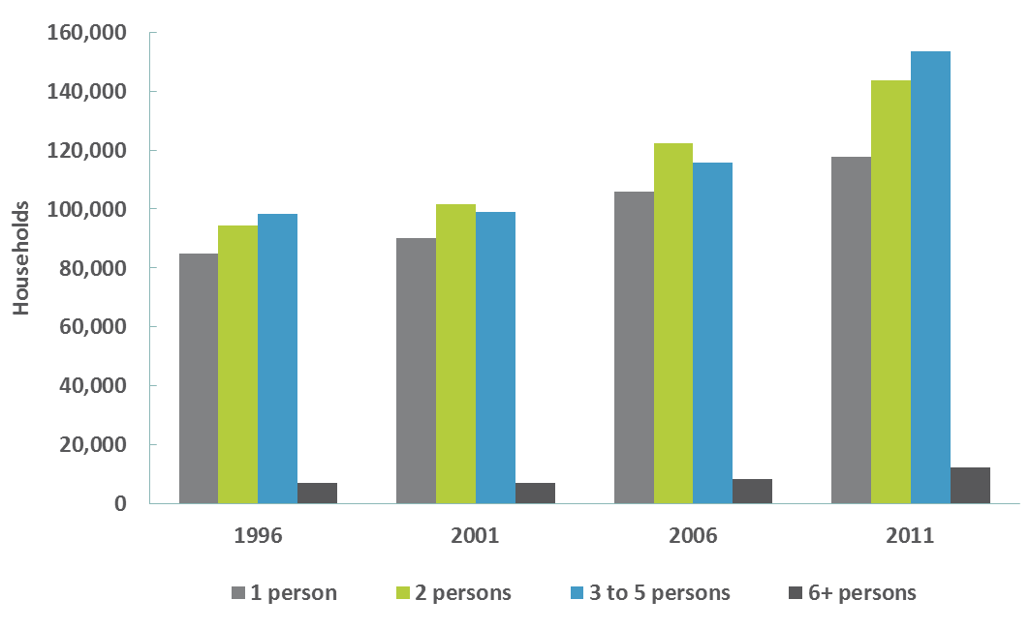
Source: ABS, Customised 2011 Census report, 2015
In terms of household composition, families (including couples with children, one parent with children, and other family households) are the most common type of household in the Victorian private rental sector. The number of family households renting privately grew by just under 50 per cent between 1996 and 2011. Between 2006 and 2011, families accounted for 45 per cent of all the growth in the private rental sector.
The most significant growth between 1996 and 2011 was in couple-only households, which grew by nearly 87 per cent.

Figure 5: Number of households renting privately by composition, 1996 to 2011
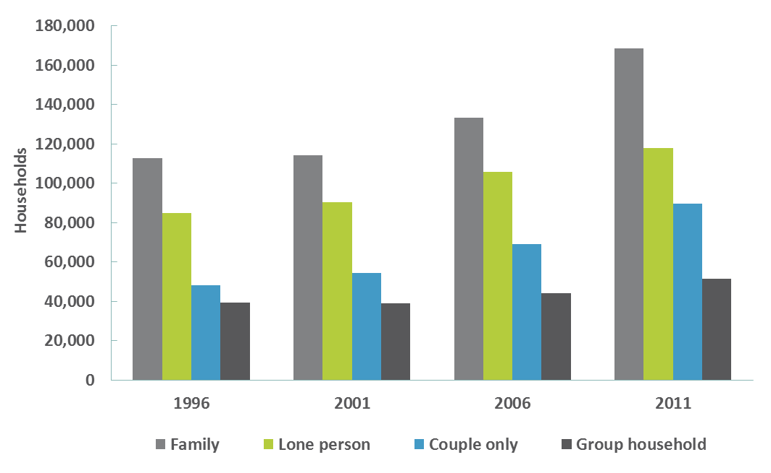
Source: ABS, Customised 2011 Census report, 2015
Between 1996 and 2011:
- Families maintained a market share of just under 39 per cent of the private rental market. However, the proportion of families making up all Victorian households fell from 49 per cent to 45 per cent.
- The proportion of couple-only households in the private rental sector increased from 16 per cent to 21 per cent, which was greater than the increase in couple-only households as a proportion of all Victorian households (23 per cent to 25 per cent).
- The proportion of lone-person households in the private rental sector, the next most common type of household after families, decreased from 29 per cent to 27 per cent. By contrast, as a proportion of all Victorian households, lone-person households increased slightly from 23 per cent to 24 per cent.
- The proportion of group households in the private rental sector decreased from 14 per cent to 12 per cent, and compared to other private rental sector household types, this category experienced a lower level of growth at 30 per cent since 1996. This is comparable with the growth of all Victorian group households over the same period, although group households comprise only 4 per cent of Victorian households.
Figure 6: Composition of private rental sector households, 1996 and 2011
Household composition | 1996 |  | 2011
Household composition | Number of  households | Per cent | Number of  households | Per cent
Families
Couple with children | 64,503 | 22.3% | 95,390 | 21.9%
One parent with children | 40,485 | 14.0% | 63,266 | 14.5%
Other family | 7,658 | 2.6% | 9,944 | 2.3%
Families total | 112,646 | 38.9% | 168,600 | 38.7%
Lone person | 84,762 | 29.3% | 117,719 | 27.1%
Couple only | 47,944 | 16.5% | 89,452 | 20.6%
Group household | 39,340 | 13.6% | 51,328 | 11.8%
Visitor only | 5,030 | 1.7% | 7,827 | 1.8%
Total | 289,722 | 100.0% | 434,926 | 100.0%
Source: ABS, Customised 2011 Census report, 2015
More than half of people living in private rental in 2011 were aged between 25 and 54 years. The most common age for people living in private rental was 25 to 34 years. The proportions of people living in private rental in each age bracket up to 44 years old were greater than the proportions of the general population in each of those age brackets.

Figure 7: Distribution of people living in private rental by age group compared to the general population, 2011
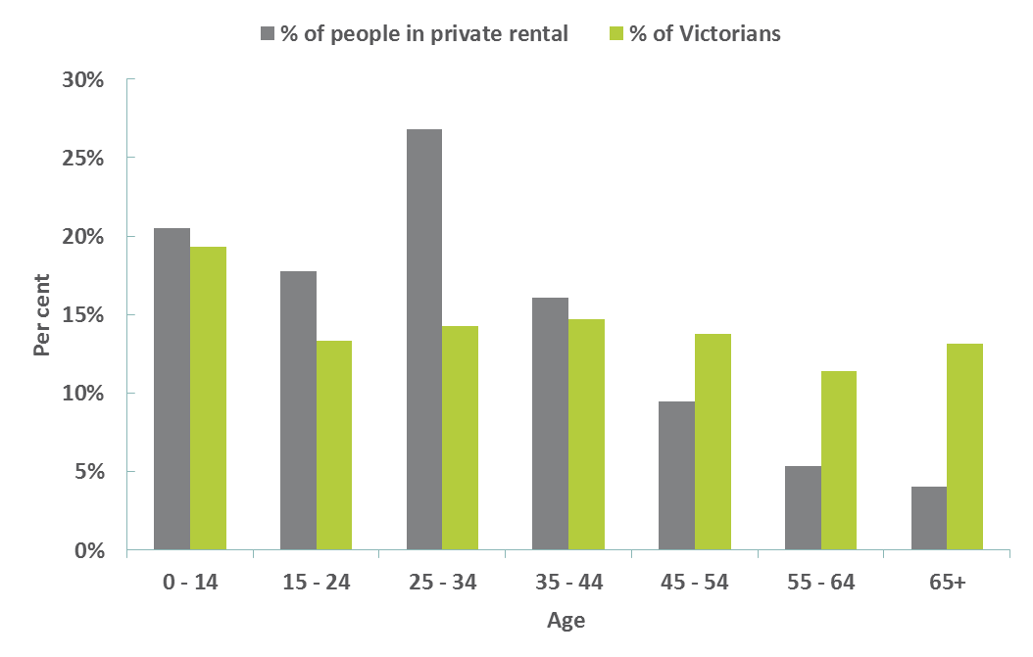
Source: ABS, Customised 2011 Census report, 2015
Although younger people outnumbered older people, the fastest growing age groups of people living in the private rental sector in 2011 were 55 years and over, in line with general Victorian population trends.

Figure 8: Growth of number of people living in private rental by age group, 1996 to 2011
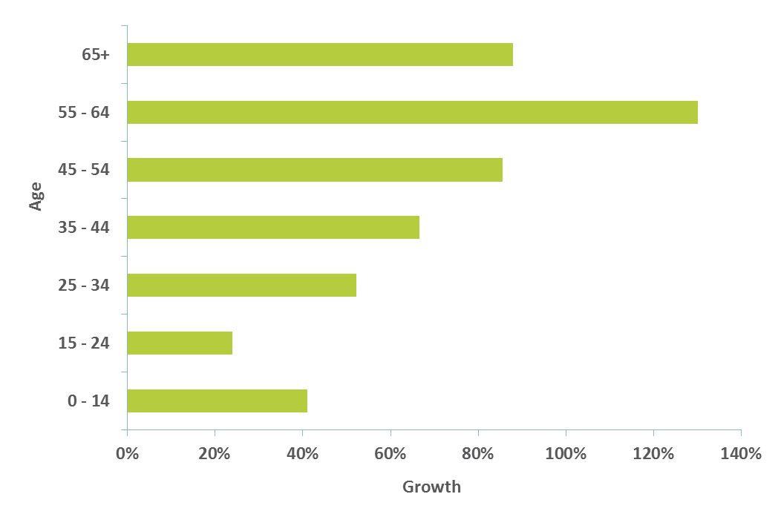
Source: ABS, Customised 2011 Census report, 2015

Who are social housing tenants?
The most common type of household living in social housing shifted from families (including couples with children, one parent with children, and other family households) in 1996 to lone-person households in 2011.
While the number of lone-person households increased by nearly 50 per cent over this period, the number of families declined by almost 16 per cent.

Figure 9: Number of households renting social housing by composition, 1996 to 2011
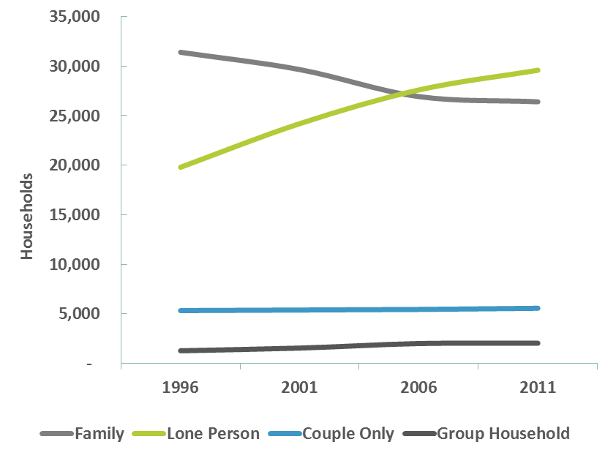
Source: ABS, Customised 2011 Census report, 2015
Although the number of couple-only and group households increased between 1996 and 2011, they make up a relatively small proportion of households renting social housing compared to lone persons and families.
Figure 10: Composition of social housing households, 1996 and 2011
Household composition | 1996 |  | 2011
Household composition | Number of households | Per cent | Number of households | Per cent
Families
Couple with children | 12,071 | 20.8% | 7,141 | 11.1%
One parent with children | 18,486 | 31.8% | 18,353 | 28.6%
Other family | 842 | 1.4% | 912 | 1.4%
Families total | 31,399 | 54.0% | 26,406 | 41.1%
Lone person | 19,800 | 34.0% | 29,590 | 46.0%
Couple only | 5,327 | 9.2% | 5,564 | 8.7%
Group household | 1,273 | 2.2% | 2,039 | 3.2%
Visitor only | 368 | 0.6% | 667 | 1.0%
Total | 58,167 | 100.0% | 64,266 | 100.0%
Source: ABS, Customised 2011 Census report, 2015
Similar to trends in the private rental sector, the number of younger people living in social housing outnumbers older people; however, both the number and proportion of older people is increasing.
In 1996, slightly over 71 per cent of people living in social housing were less than 45 years old. By 2011, the proportion of people in this age bracket had declined to 60 per cent. Over the same period, the proportion of people in social housing aged 45 years and over increased from 29 per cent in 1996 to 40 per cent in 2011.
Figure 11: Distribution of people living in social housing by age group, 1996 and 2011
Age | 1996 |  | 2011
Age | Number of people | Per cent | Number of people | Per cent
0-14 years | 44,376 | 30.9% | 31,531 | 23.3%
15-24 years | 19,793 | 13.8% | 20,421 | 15.1%
25-34 years | 19,677 | 13.7% | 13,258 | 9.8%
35-44 years | 18,319 | 12.7% | 15,816 | 11.7%
45-54 years | 12,138 | 8.4% | 16,734 | 12.4%
55-64 years | 9,943 | 6.9% | 15,220 | 11.3%
65-74 years | 10,962 | 7.6% | 11,309 | 8.4%
Over 75 years | 8,552 | 6.0% | 10,915 | 8.1%
Total | 143,760 | 100.0% | 135,204 | 100.0%
Source: ABS, Customised 2011 Census report, 2015
As in the private rental sector, the fastest growing age groups of people living in social housing were people aged 55 years or over. The number of people living in social housing aged between 55 and 64 increased by over 53 per cent between 1996 and 2011. Over the same period, the number of people aged between 25 to 34 years decreased by 33 per cent.

What type of homes do tenants rent?

What type of homes do private tenants rent?

Type of homes
Victorian households renting privately mostly rent houses (either stand-alone or semi-detached), with less than a third renting in multi-unit properties (flats, units or apartments).
Between 1996 and 2011:
- semi-detached and stand-alone properties increased from 64 per cent to 69 per cent of privately rented homes, and
- multi-unit properties declined by 4 per cent to 30 per cent of privately rented homes.

Figure 12: Type of private rental sector homes, 1996 and 2011
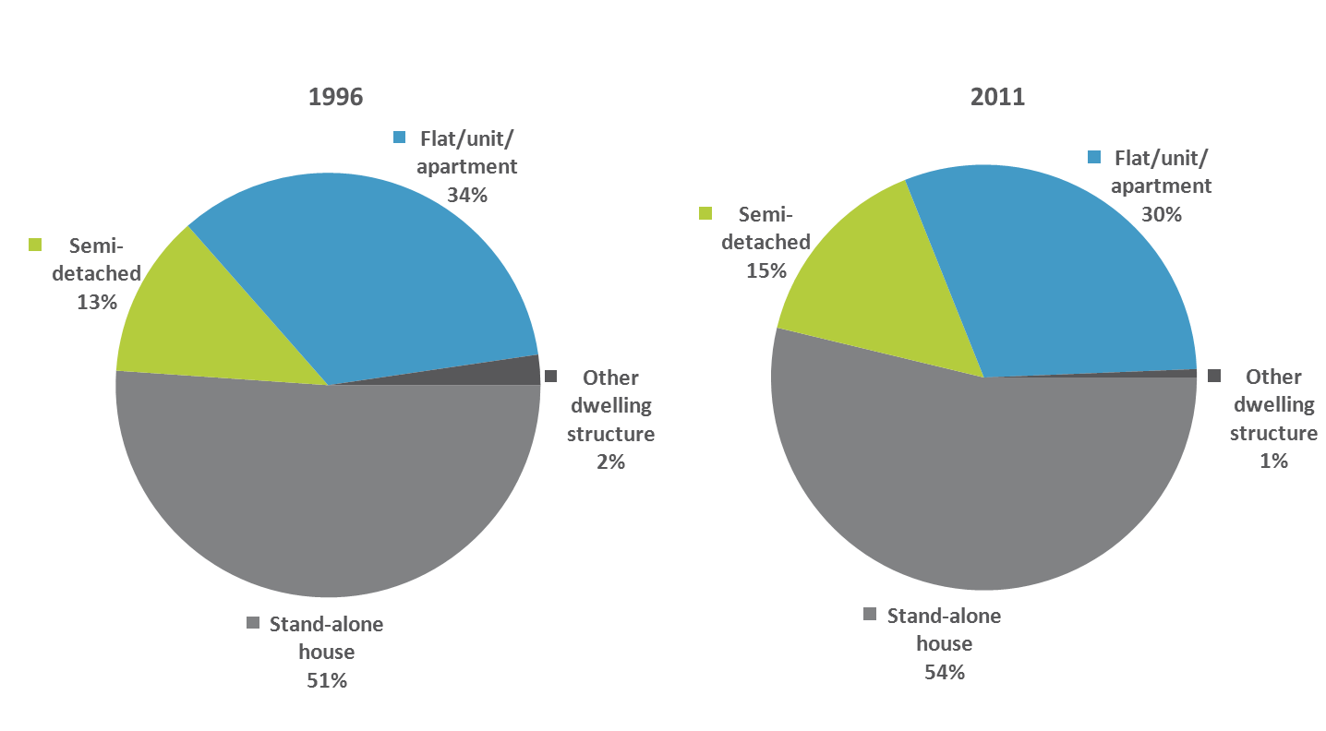
Source: ABS, Customised 2011 Census report, 2015
While the proportion of multi-unit properties in the private rental sector declined, the proportion of multi-unit properties across all Victorian occupied households increased.
A 2013 Australian Housing and Urban Research Institute (AHURI) report analysing national ABS data noted an increase of multi-unit properties within the general housing stock and its relative decline within the private rental sector, and suggested that this may be due to factors such as:
- the movement of rental households to outer suburbs, where apartments are less common
- growing numbers of renting families with children, and
- landlord investors preferring detached properties that they can better control by not having to deal with owners corporations.

Size of homes
Victorian households renting privately are increasingly renting homes with more bedrooms.
Between 1996 and 2011:
- the most common size of privately rented property increased from a two bedroom to a three bedroom home
- the proportion of privately rented one and two bedroom properties decreased from a 55 per cent market share to 47 per cent, and
- the proportion of privately rented properties with four or more bedrooms increased from an 8 per cent market share to 12 per cent.
By 2011, homes with three or more bedrooms accounted for over half of all private rental properties.
Figure 13: Distribution of private rental sector homes by number of bedrooms, 1996 and 2011
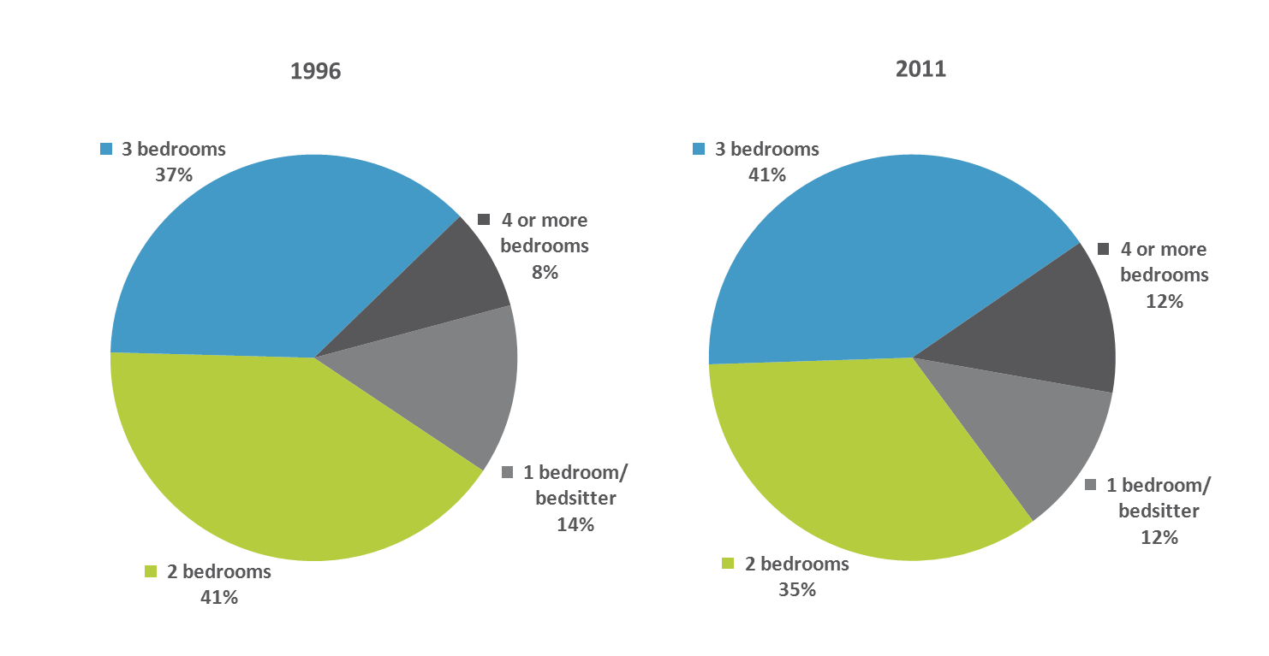
Source: ABS, Customised 2011 Census report, 2015

What type of homes do social housing tenants rent?

Type of homes
While most households living in social housing continue to rent houses (either stand-alone or semi-detached), the proportion that rent a stand-alone house is gradually declining. This is the reverse of the trend in the private rental sector where the proportion of stand-alone houses is increasing.
Between 1996 and 2011:

- stand-alone properties decreased from 48 per cent to 44 per cent
- semi-detached properties increased from 14 per cent to 17 per cent, and
- multi-unit properties increased by one per cent to 39 per cent of social housing homes.

Figure 14: Type of social housing homes, 1996 and 2011
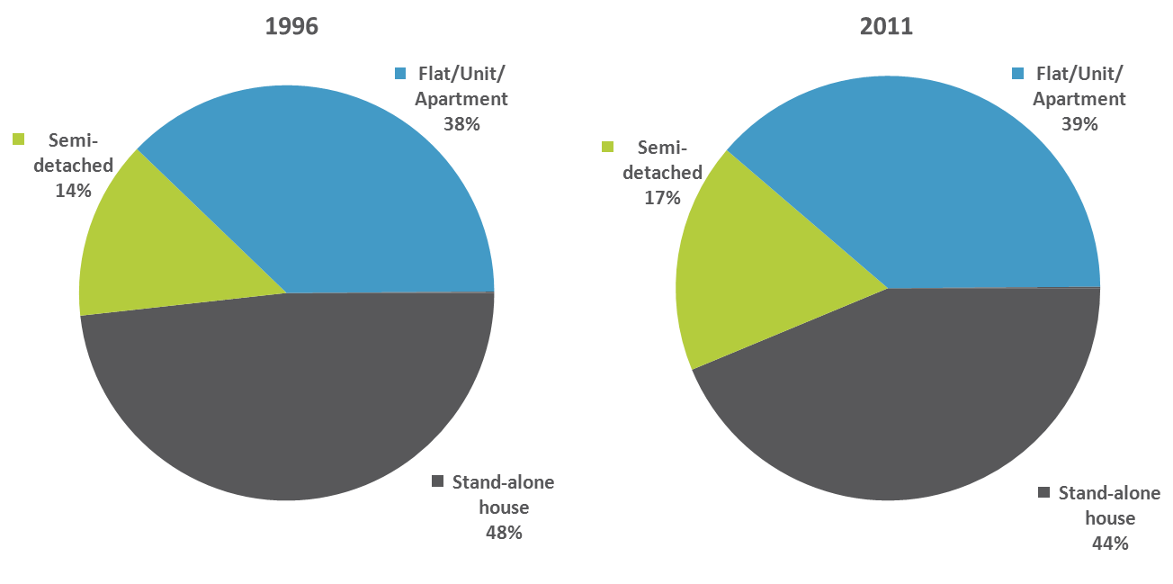
Source: ABS, Customised 2011 Census report, 2015

Size of homes
In comparison to the private rental sector, more social housing tenants rent smaller homes.
Social housing tenants most commonly rent two and three bedroom homes. However, between 1996 and 2011 the proportion of social housing tenants who rented one and two bedroom homes increased while those renting three bedroom homes decreased by 10 per cent.

Figure 15: Distribution of social housing homes by number of bedrooms, 1996 and 2011
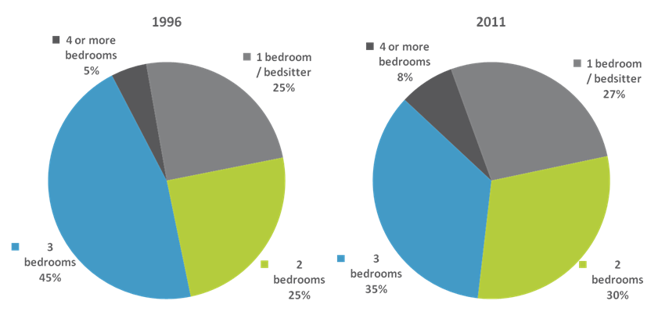
Source: ABS, Customised 2011 Census report, 2015

How often do tenants move?

How often do private tenants move?

Moving within the private rental sector
Victorian households renting privately are less likely to move than in the past, but they are still more likely to move than households in other tenures (non-renter households), such as homeowners.
In 1996, most households renting privately (over 80 per cent) had changed their address during the previous year. By 2011, there had been a strong shift in the opposite direction and the majority of households renting privately (around 60 per cent) had remained at the same address for at least one year.
Figure 16: Private rental sector mobility within the last year, 1996 and 2011
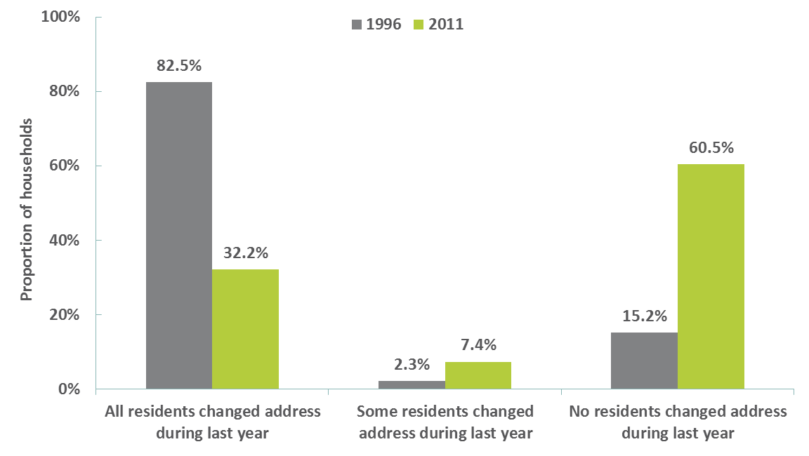
Source: ABS, Customised 2011 Census report, 2015
A corresponding trend is observed when looking at non-renter households. This suggests that for both households renting privately and non-renter households, mobility over one year has declined over time.
Despite this decline, tenants renting privately are still more likely to move than non-renter households. In 1996, almost three times more households renting privately moved within a one-year period compared with non-renter households. In 2011, this ratio had increased and households renting privately were five times more likely to move than non-renter households.

Figure 17: Household mobility where all residents moved within the last year, 1996 and 2011
 | 1996 | 2011
Proportion of households renting privately | 82.5% | 32.2%
Proportion of non-renter households | 26.5% | 6.1%
Source: ABS, Customised 2011 Census report, 2015
There are a number of reasons why households may move, including reasons that are voluntary, involuntary or a mixture of both. However, compared to non-renter households, AHURI analysis suggests that moves in the private rental sector are more likely to be a constrained decision. This means a decision to move may be affected by external factors (such as the landlord’s decision to terminate a tenancy) and/or internal pressures (such as issues of affordability, or poor quality and/or unsuitable housing).

Moving out of the private rental sector
In the decades following the Second World War, people tended to transition through rental housing before they became homeowners, only staying long term in tenancy as a last resort.
Short-term tenancies continue to be the most common length of tenancies in the private rental sector in Australia. However, a recent AHURI report noted that there is a significant proportion of long-term tenants, and this has increased over time.
In 1994, short-term tenants (those who had been tenants continuously for one to four years) made up around 37 per cent of private tenants in Australia, while long-term tenants (those who had been tenants continuously for more than 10 years), comprised 27 per cent.
The AHURI report found that by 2007-08, the proportion of long-term tenants had increased, comprising 34 per cent of private tenants in Australia.

Figure 18: Short-term, medium-term and long-term tenants as a proportion of the Australian private rental sector, 2007-08
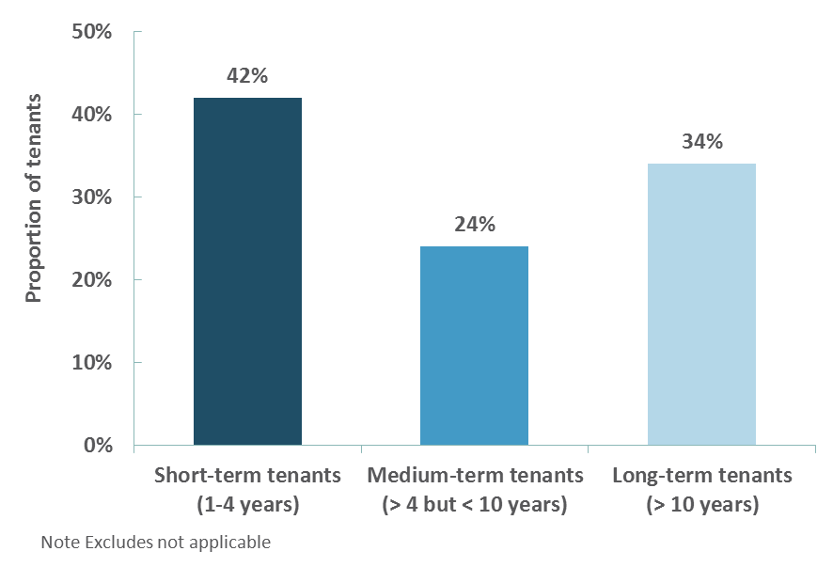
Source: AHURI

How often do social housing tenants move?
Households living in social housing are less likely to move than in the past, and are less likely to move compared to households renting privately.
In 1996, roughly the same proportion of Victorian households renting social housing (48 per cent) changed their address during the previous year as those that had remained at the same address for at least one year.
However, by 2011 social housing tenant mobility had reduced with less than 11 per cent changing their address during the previous year, and over 85 per cent remaining at the same address for at least one year.
Figure 19: Social housing mobility within the last year, 1996 and 2011
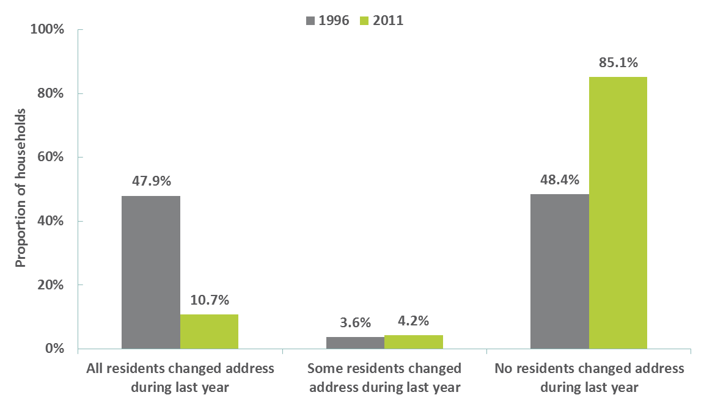
Source: ABS, Customised 2011 Census report, 2015

How affordable is it to rent?
Rental affordability is a component of the broader issue of housing affordability in Victoria.
Housing affordability is affected by a range of ‘supply-side’ and ‘demand-side’ issues and policy considerations. Many of these issues, including taxation policy, land use planning policy, home loan interest rates and the availability of credit, are outside the scope of residential tenancies regulation.
Another relevant factor is that, for some tenants, maintaining rental affordability may necessitate trade-offs in terms of location, access to amenities, and property size and type. Other tenants may choose to pay more towards rent as a trade-off for obtaining their desired location or access to amenities. Some higher-income households may be able to afford to pay a substantial proportion of their income towards rent without placing the household under financial stress.
An increasing proportion of Victorian households renting privately are paying more of their income towards rent.
In 1996, around 35 per cent of all households renting privately paid more than 30 per cent of their income in rent. By 2011, this had increased to about 38 per cent, with the strongest growth in the proportion of households paying more than 50 per cent of their income towards rent.
Figure 20: Rent as a proportion of household income for private rental housholds, 1996 and 2011
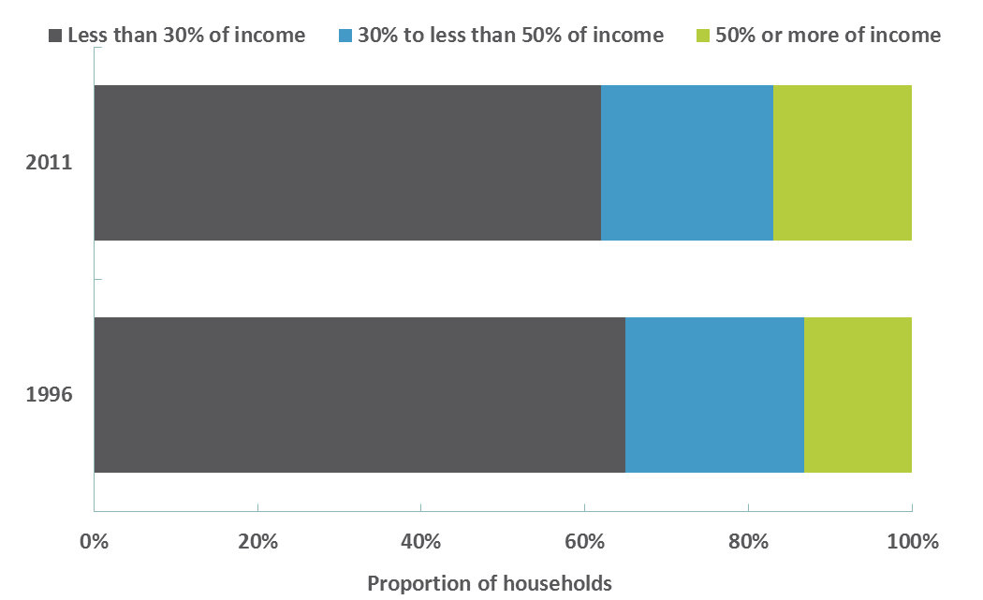
Source: ABS, Customised 2011 Census report, 2015
Looking at low-income households in particular, this trend is even more significant.
One measure of housing affordability is to consider the proportion of household income paid towards rent by low-income households, that is, those whose income is in the bottom 40 per cent of all Victorian households. Low-income households spending more than 30 per cent of their income in rent are said to be experiencing ‘rental stress’, and those spending more than 50 per cent of their income in rent are said to be experiencing ‘severe rental stress’.

Figure 21: Rent as a proportion of household income for low-income private rental households, 1996 and 2011
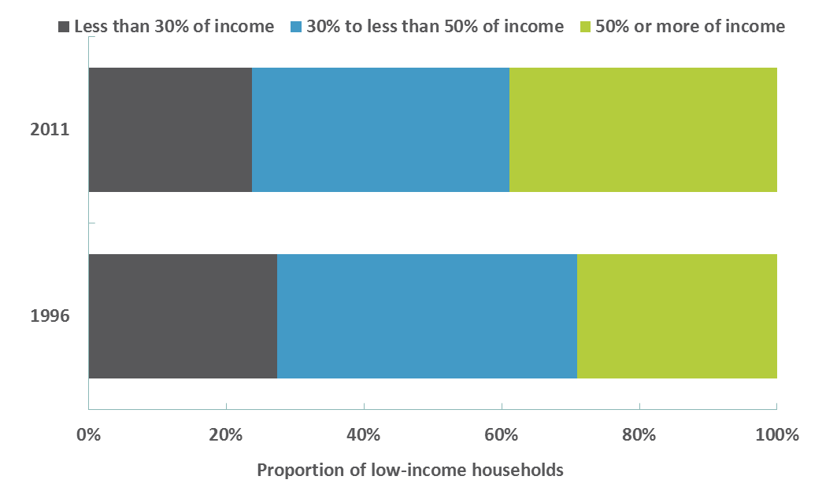
Source: ABS, Customised 2011 Census report, 2015
In 1996, almost 73 per cent of low-income households were experiencing rental stress. By 2011, this had increased to just over 76 per cent.
Of the low-income households experiencing rental stress, there was a marked increase in those experiencing severe rental stress. Between 1996 and 2011, the proportion of low-income households experiencing severe rental stress increased from 29 per cent to just under 39 per cent.
Although the cost of rent cannot be accurately compared from 1996 to 2011 in the figure below as it is not adjusted for inflation, it is interesting to note that the range of rents across the sector has changed markedly, moving from a narrow, regular distribution in 1996 to an irregular, broad distribution in 2011. In 1996, private rentals were concentrated at the lower-cost end of the market, whereas in 2011, there was a greater spread across weekly rental categories.

Figure 22: Distribution of weekly rent for private rental households , 1996 and 2011
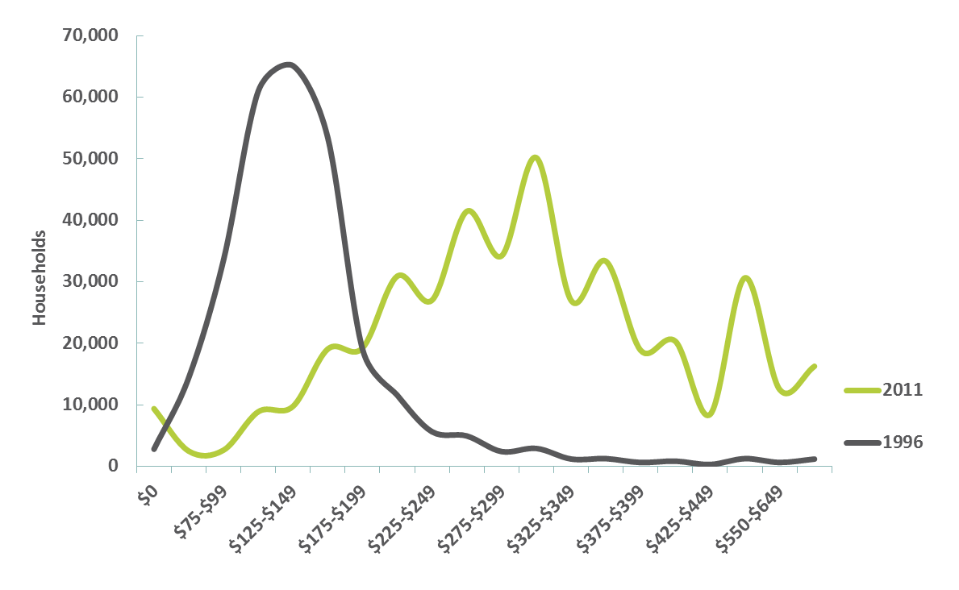
Source: ABS, Customised 2011 Census report, 2015
This change suggests that in 2011, there were people living in the private rental market representing a wider range of income levels than in 1996. A number of factors could be contributing to tenants choosing to rent more expensive properties, including lifestyle choices and greater mobility, choice of alternative investments and reduced affordability of purchasing a home.
Vacancy rates
Between 2008 and 2013, vacancy rates in metropolitan Melbourne increased from one per cent to just over 3 per cent. A 3 per cent vacancy rate is considered to represent a balance between the supply and demand for rental housing, and vacancy rates lower than 3 per cent could represent a heightened demand for rental housing.
Figure 23: Metropolitan Melbourne vacancy rate, March quarter, 2007 to 2013

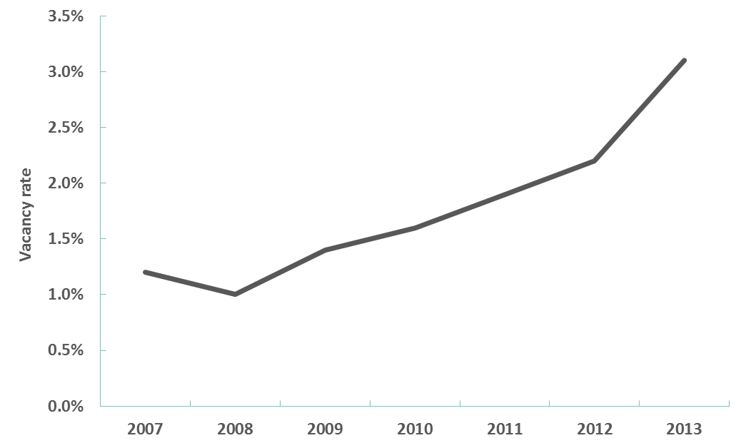
Source: Department of Health and Human Service Rental Reports, 2007 to 2013

Affordable housing for low-income households in the private rental sector
Most Victorian private tenants (78 per cent) rent in the Melbourne metropolitan area. The most recent Rental Affordability Snapshot by Anglicare Australia indicated that the vast majority of rental properties considered by the Snapshot analysis to be affordable and appropriate for households living on low incomes in the Melbourne metropolitan area were located in the outer suburban growth corridors, fringe areas, and semi-rural locations. In contrast, the fewest affordable and appropriate rentals were located in the inner metropolitan areas of Melbourne.
The Anglicare Australia Snapshot analysis of advertised private rental properties on the weekend of 11-12 April 2015 in metropolitan Melbourne and a selection of regional and coastal areas found that, for the majority of low-income households analysed, access to affordable and appropriate rental properties was very poor or negligible.

Where else do private tenants live?
Tenants renting privately also live in caravan parks, residential parks (where they own their movable dwelling but rent the underlying site), and rooming houses.
Between 1996 and 2011, the number of households renting in caravan parks and residential parks increased by more than 6 per cent to just over 3,400 households.
Some caravan parks and residential parks specialise in providing accommodation for specific population groups such as people who have retired or semi-retired.
Notable characteristics of households living in caravan parks and residential parks in 2011 included:
- lone-person households (74 per cent) followed by families (including couples with children, one parent with children, and other family households) at 22 per cent
- low income households (84 per cent) with a income of less than $968 a week
- individuals aged 45 years of age or over (55 per cent), and
- individuals who were either unemployed or not in the workforce (60 per cent).
In April 2015, there were 1,099 registered rooming houses in Victoria, with 73 per cent operated by individuals and 27 per cent by businesses. Most are located in south-eastern Melbourne and regional centres.
A recent AHURI study noted an increase in the:
- proportion of larger suburban rooming houses
- investment by small-scale investors in rooming houses, and
- professional management of rooming houses.
The study found that rooming houses often accommodate the more vulnerable and disadvantaged tenants, with increased demand from international and domestic students, travellers, low-income earners and young and mobile workers.

What else do we know about private tenants?
Other notable characteristics of private tenants include:
- There was a 58 per cent increase in the number of private tenants renting in Melbourne between 1996 and 2011. Over the same period, the Victorian population grew by 22 per cent.
- Female tenants continue to marginally outnumber males, making up slightly over 50 per cent of the private rental sector in 2011, consistent with the composition of the Victorian population.
- Almost 28 per cent of private tenants speak languages other than English at home, compared to 24 per cent of the Victorian population. Of these, only 4 per cent in 2011 had low proficiency in English.
- The number of Aboriginal and/or Torres Strait Islander tenants renting privately increased from around 5,000 in 1996 to around 10,000 by 2011.
- Most private tenants are employed, at almost 70 per cent in 2011, increasing from just over 60 per cent in 1996.

Questions for consideration – Tenants
- (a) What are the key issues for regulating the private rental sector that arise from the:
(i) growing number of families and proportion of older tenants
(ii) tenants renting for longer periods, and
(iii) decreasing proportion of tenants renting in multi-unit properties (flats, units or apartments), especially given the increasing proportion of households living in multi-unit properties more generally?
  - How should residential tenancies regulation take into account these trends in the private rental sector?
- How do changes in tenant mobility impact on the current balance of rights and responsibilities between landlords and tenants?
- What situations trigger issues of affordability in the rental housing sector, and how do these affect tenants and the choices they make?
- From a tenant’s perspective, what role does residential tenancies regulation play in enabling access to rental housing?

Landlords
Key points
- The number of landlords is increasing, and is being driven by those who own a single rental property.
- The majority of landlords rely on negative gearing to support their investment, and those who do hold properties for shorter periods than those who do not negatively gear.
- Landlords buy and sell rental properties for a number of financial and personal reasons such as to provide an income stream for retirement.
- The number of landlords that use agents to manage their rental properties is increasing.
- The Director of Housing is the largest landlord in Victoria, with over 65,000 public rental housing properties.
- Community housing organisations are a growing sector of the rental market, with over 19,000 properties under management.

How many landlords are there?
Between 1995 and 2012, both the number and proportion of Victorians investing in residential rental property and receiving income from that property (private landlords) increased. This excludes interstate and overseas investors, institutions and other organisations investing in residential property, which are not captured in the ABS data.
In 1995-96, there were an estimated 184,600 residential landlords in Victoria, amounting to just over 5 per cent of Victorians aged 15 years and over. By 2011-12, the estimated number of landlords had increased by over 94 per cent to 358,900, or almost 8 per cent of Victorians aged 15 years and over. Of these landlords, 80 per cent resided in Melbourne with the remaining landlords residing in regional and rural Victoria.
Victoria’s largest landlord is the Director of Housing, who provides 65,000 public housing properties. Community housing is delivered by eight registered housing associations and 34 housing providers managing 19,000 properties.

Who are they?
In 2011-12, the majority of landlords (58 per cent) were males, and the most common age of landlords was between 45 to 54 years.
Seventy seven per cent of Victorian landlords were also owners of the property they themselves lived in. An AHURI study in 2012 found that in 2009-10, 71 per cent of Australian landlords were homeowners and 29 per cent were tenants. One suggested explanation for the large number of tenants themselves leasing out an investment property was a desire by younger households to have equity in a property but not being able to afford ownership in the area in which they wish to live.
The majority of Victorian landlords are in the higher disposable income brackets.
In 2011-12, almost 68 per cent of private landlords had a disposable income of $728 or more a week. Seventeen per cent of private landlords had a disposable income of between $431 to S728 a week, and 15 per cent were in the two lowest disposable income brackets, with a disposable income of $431 or less a week.
In contrast, less than 38 per cent of people who were not landlords had a disposable income of $728 or more a week in 2011-12. Just over 42 per cent of people who were not landlords were in the two lowest disposable income brackets, with a disposable income of $431 or less a week.

Figure 24: Distribution of private landlords and non-landlords by disposable weekly income quintiles, 2011-12
Disposable weekly income | Receiving income from rental property (private landlords) | Not receiving income from rental property (non-landlords) | All Victorians
Less than $260 | 10.9% | 20.8% | 20.0%
$260 - $431 | 4.3% | 21.3% | 20.0%
$432 - $727 | 16.9% | 20.3% | 20.0%
$728 - $1,068 | 21.9% | 19.8% | 20.0%
Over $1,068 | 46.0% | 17.8% | 20.0%
Source: ABS, Customised Survey of Income and Housing report, 2015

How many rental properties do landlords own?
In 2011-12, almost 12 per cent of Victorian households owned one or more residential rental properties. Of these households, the majority (73 per cent) owned only one rental property.

Figure 25: Proportion of households owning residential rental properties (excluding current residence), 2011-12
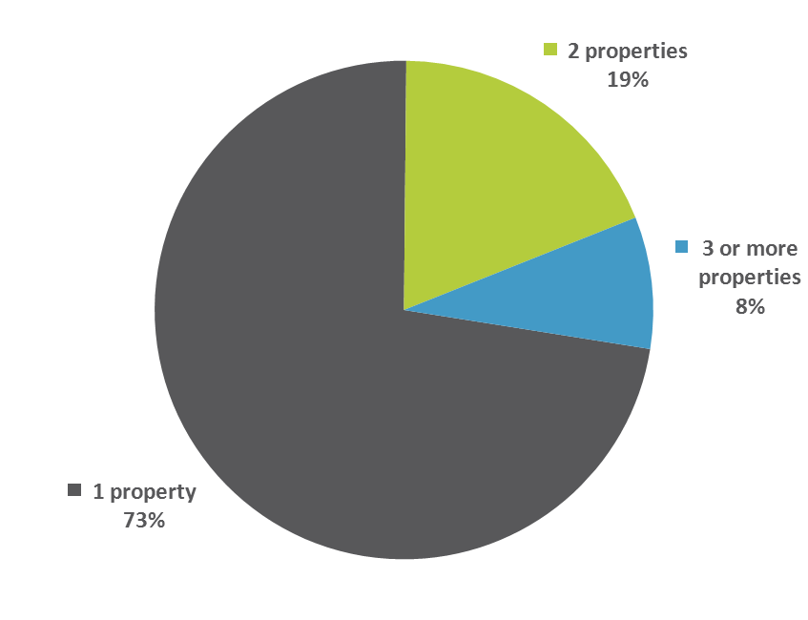
Source: ABS, Customised Survey of Income and Housing report, 2015
The 2012 AHURI study found a link between the income and age of landlords. In 2009-10, the proportion of Australian landlords owning at least one rental property increased with household income and also increased with age up to 64 years.
However, while there has been a growth in investment in the private rental sector, this has been from an increase in the number of small-scale household investors buying single properties rather than existing investors increasing their property portfolios. New investment focussed on:
- established properties rather than new stock, and
- detached properties, particularly in outer suburban areas.
Investment in established properties is considered to provide the opportunity for low risk capital gains.
The purchase of detached properties on the urban fringe is seen to reflect small investors being more interested in rates of return, which are higher in the outer suburbs of Melbourne, the lower management costs of newer properties, and having a rental property close to where they live.

Why do landlords buy and sell rental properties?
A 2010 AHURI report tracked a nationally representative sample of private rental investors from their first investment and found that:
- one in four investors exit the rental property market within a year
- after the first year there is a steep decline in the rate of exit from the rental property market
- retirement status is an important factor influencing decisions about when and whether to sell investment properties, and
- negatively geared investors are more likely to exit the market.
Current taxation policy in Australia has given rise to the practice of negative gearing, whereby investors are prepared to make a net loss on the rental income of their investment property in the expectation of realising a capital gain when they eventually sell the property. In the meantime, the net losses they make (because their interest repayments and other costs associated with the property exceed the rental income) can be used to reduce their taxable income.
Negative gearing is a key financial consideration for rental property investors. The Henry Tax Review of 2010 reported that 70 per cent of investors in Australia rely on negative gearing, and are likely to hold their rental properties for shorter periods than those who do not negatively gear.
Some of the factors reported by AHURI influencing individuals’ decisions to buy and sell rental properties include:
- investor age and retirement status (rental income can be more desirable than shares for meeting weekly expenses, however rental investments are not exempt under the pension assets test)
- children and other family members (a motive can be the prospect of a future home for parents’ children)
- windfall gains (eg bequests, inheritance) or a buyer purchasing a property with existing tenants
- changing personal circumstances (pooling or division of assets due to a change in personal relationships)
- attitudes to risk and saving (property investment appeals to the risk averse because it is perceived as a familiar, low risk, tangible asset that they can see and control; property representing a ‘bricks and mortar’ investment), and
- to a lesser extent, the market environment (how the market is performing).

How many landlords use agents?
While a tenancy agreement is a contract between a landlord and tenant, it is common practice for a landlord to engage an estate agent to manage the property on their behalf. The estate agent has a dual function: their role is to act on behalf of the landlord to represent their interests, but they also operate as an intermediary between the landlord and tenant.
Within the private rental sector, the role of estate agents has grown significantly. The proportion of private rental households whose landlord uses an estate agent or property manager grew from 60 per cent in 1996 to nearly 74 per cent in 2011.

Figure 26: Landlord use of estate agents in the private rental sector, 1996 and 2011
 | 1996 |  | 2011
 | Households | % of private rental market | Households | % of private rental market
Estate agent | 174,362 | 60.1% | 321,183 | 73.8%
No agent  (self managing landlord) | 115,559 | 39.9% | 113,995 | 26.2%
Total | 289,921 | 100.0% | 435,178 | 100.0%
Source: ABS, Customised 2011 Census report, 2015

Questions for consideration – Landlords
- How do investor trends affect the current and future management of tenancies and the availability of rental housing?
- From a landlord’s perspective, how does residential tenancies regulation influence the ongoing supply of rental housing?
- How do estate agents influence the relationship between landlord and tenant, and what implications does the increasing use of agents as property managers have for residential tenancies regulation?

Residential tenancies disputes
Key points
- When parties need help resolving disputes, they can seek conciliation from Consumer Affairs Victoria, and low-cost resolution at VCAT. Most VCAT applications are initiated by landlords.
- The most common dispute issues at VCAT are around landlords seeking possession for unpaid rent, and landlords seeking bond or compensation for unpaid rent or damage.
A variety of issues can arise in residential tenancies, with the property being, on the one hand, a home for the tenant, and on the other hand, an asset for the landlord. One of the purposes of the Residential Tenancies Act 1997 (the current Act) is to provide for the inexpensive and quick resolution of disputes, as issues arise. The current Act aims to do this by defining the rights and duties of landlords and tenants to help them to identify their responsibilities, and to navigate and resolve issues quickly.
Landlords and tenants unable to resolve their disputes between themselves can seek conciliation services from Consumer Affairs Victoria for a voluntary outcome, or can apply to VCAT for a binding outcome and redress.
Consumer Affairs Victoria provides support and advice concerning rights and responsibilities under the current Act, conducts inspections and assessments for residential tenancies upon request, and helps to resolve disputes between landlords and tenants through its conciliation service. Consumer Affairs Victoria also funds the Tenancy Advice and Advocacy Program, which supports vulnerable and disadvantaged people with private rental matters.
In the 2013-14 financial year, Consumer Affairs Victoria received almost 80,000 residential tenancies enquiries, with the most common issues being termination and repairs and maintenance. Consumer Affairs Victoria also received over 2,600 residential tenancies complaints (excluding requests for inspection), with the most common issues being repair and maintenance, and bonds.
Where disputes cannot be conciliated, there is a need for tenants and landlords to seek resolution at minimal cost and in an accessible way. This was recognised by the 1980 Act, which aimed to do this by establishing a Residential Tenancies Tribunal. The current Act maintains this approach, allowing parties to seek independent third-party resolution of disputes at VCAT.
Over the last several years, the number of applications to VCAT's Residential Tenancies List has increased by roughly 5 per cent a year, to over 61,000 a year in 2013-14. This increase reflects Victoria’s growing population and the resulting higher number of tenancies, rather than an increase in the number of disputes per tenancy.
Approximately 92 per cent of applications are initiated by landlords (which include self-managed landlords, landlords represented by estate agents, and the Director of Housing).
In terms of subject matter, most of the applications made in 2013-14 were made by landlords to regain possession of their rented property because the tenant had failed to pay rent. The second most common type of application was made by landlords seeking a payment of all or part of the bond and/or compensation for rent owing or damage to the property at the end of a tenancy.

Questions for consideration – Residential tenancies disputes
- What more could be done, or what could be done differently, to enable landlords and tenants to effectively manage their tenancy relationship?
- Are the current arrangements for resolving disputes and providing access to redress for both landlords and tenants sufficient, or are other mechanisms needed?
- What factors contribute to tenants exercising, or not exercising, their rights?

ABS, Australian Census of Population and Housing and Australian Survey of Income and Housing from ABS Customised report, 2015.
‘Reform of the Federation White Paper: Roles and Responsibilities in Housing and Homelessness’, Issues Paper 2, December 2014, Australian Government, Department of Prime Minister and Cabinet, page 1.
Ibid, page 28.
‘2015 Rental Affordability Snapshot’, Anglicare Australia, page 18.
Provisions of the current Act may apply to some forms of holiday accommodation in certain limited circumstances, for example where a person occupies a room as a main residence for at least 60 consecutive days.
Second Reading Speech for Residential Tenancies Bill, Legislative Council, 6 December 1978.
The 1997 Act consolidated the Residential Tenancies Act 1980, the Caravan Parks and Movable Dwellings Act 1988, and the Rooming Houses Act 1990.
Second Reading Speech for Residential Tenancies Bill, Legislative Assembly, 30 October 1997.
‘Other rental’ includes tenancies where the landlord was described as ‘employer’ or not stated.
‘New Directions for Social Housing: A Framework for a Strong and Sustainable Future’, Victorian Government, March 2014, page 5.
According to ABS Census data, the proportion of Victorian households occupying a multi-unit dwelling increased from 12.1 per cent in 1996 to 13.5 per cent in 2011 (ABS, Customised 2011 Census report, 2015).
‘Long-term private rental in a changing Australian private rental sector’, Wendy Stone, Terry Burke, Kath Hulse and Liss Ralston, for the Australian Housing and Urban Research Institute, Swinburne-Monash Research Centre, July 2013, AHURI Final Report No. 209, page 11.
Ibid, pages 21-22.
Ibid, page 25.
Ibid, page 26.
’2015 Rental Affordability Snapshot’, see note Error: Reference source not found, pages 9, 18.
See, for example, ‘Australian Housing Outlook 2014-2017’ prepared by BIS Shrapnel for QBE Insurance, October 2014, page 21 and ‘Public housing tenants moving for work’, AHURI Evidence Review 063, Matthew Lovering, 10 September 2014, page 2.
ABS, Customised 2011 Census report, 2015.
‘2015 Rental Affordability Snapshot’, see note Error: Reference source not found, page 91.
Ibid, page 89.
ABS, Customised 2011 Census report, 2015.
Data recorded on the Rooming House Register hosted by Consumer Affairs Victoria at www.consumer.vic.gov.au/roominghouseregister.
‘Rooming house features: governing for growth, transparency and fairness’, Victorian Discussion Paper, Tony Dalton, Kath Hulse and Hal Pawson, for the Australian Housing and Urban Research Institute, RMIT University, Swinburne University of Technology and the University of New South Wales, February 2015, page 4.
Ibid, page 12.
ABS, Customised 2011 Census report, 2015.
ABS, Customised Survey of Income and Housing report, 2015.
‘New Directions for Social Housing: A Framework for a Strong and Sustainable Future’, see note 10, page 5.
ABS, Customised Survey of Income and Housing report, 2015.
‘The Australian private rental sector: changes and challenges’, Kath Hulse, Terry Burke, Liss Ralston and Wendy Stone, for the Australian Housing and Urban Research Institute, Swinburne Research Centre, July 2012, AHURI Positioning Paper No. 149, page 29.
Ibid.
Ibid, pages 30-31.
‘Long-term private rental in a changing Australian private rental market’, see note Error: Reference source not found, page 7.
‘Secure occupancy in rental housing: conceptual foundations and comparative perspectives’, Kath Hulse, Vivienne Milligan and Hazel Easthorpe, for the Australian Housing and Urban Research Institute Swinburne-Monash Research Centre and UNSW-UWS Research Centre, July 2011, AHURI Final Report No. 170, page 39.
‘Long-term private rental in a changing Australian private rental market’, see note Error: Reference source not found, page 12.
Ibid.
‘Factors shaping the decision to become a landlord and retain rental investments’, Gavin Wood and Rachel Ong, for the Australian Housing and Urban Research Institute, RMIT Research Centre and Western Australia Research Centre, February 2010, AHURI Final Report No. 142, pages 1, 24, 27-28, 30.
Australia’s Future Tax System, Report to the Treasurer (Henry Review), The Treasury, Canberra, 2010, Part 2, pages 69 and 419. See also ‘Secure occupancy in rental housing: conceptual foundations and comparative perspectives’, see note Error: Reference source not found, page 39.
‘Factors shaping the decision to become a landlord and retain rental investments’, see note Error: Reference source not found, pages 7-11. See also ‘Understanding what motivates households to become and remain investors in the private rental market’, Tim Seeling, Alice Thompson, Terry Burke, Simon Pinnegar, Sean McNelis and Alan Morris, for the Australian Housing and Urban Research Institute, Queensland, UNSW-UWS, and Swinburne-Monash Research Centres, March 2009, AHURI Final Report No. 130, pages 21-26.
Victorian Civil and Administrative Tribunal Annual Report for 2013-14, pages 20-21.
Estimate provided by the Victorian Civil and Administrative Tribunal for the period July 2013 to March 2015.
Victorian Civil and Administrative Tribunal Annual Report for 2013-14, page 20.

