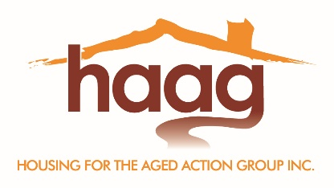

Housing for the Aged Action Group
Management Committee Nomination Form 2020-2023

I wish to nominate: ………………………………………………………………(Name of Nominee)
for the position of:

Chairperson ☐ | Secretary ☐ | Ordinary Member ☐
Vice Chairperson ☐ | Treasurer ☐

Acceptance by nominee
Signature of nominee: ………………………………………………………………
Date: ………..…...………………………………

Nomination made by
Name of nominator: ……………………….………………………………………..
Signature of nominator: ……………………….…………………………………..
Date: ………..…...………………………………

Nomination seconded by
Name of seconder: ……………………….………………………………………….
Signature of seconder: ……………………….…………………………………….
Date: ………..…...………………………………

It is a requirement of the Housing for the Aged Action Group (HAAG) Constitution that all nominations for the Management Committee are received by HAAG’s Secretary at least 7 days before the Annual General Meeting, in this case no later than 5pm, Thursday 12th November 2020.

Nominations can be received via:
Post: 1st Floor, 247-251 Flinders Lane, Melbourne 3000
Email: haag@oldertenants.org.au

If you are nominating for the Committee of Management, we will ask you to provide a brief profile of yourself and your interests to be distributed at the AGM.

*You must be a current member to make a nomination and you must be a current member to accept any nominations. The nominator, nominee and seconder of the position, must also be a current member.

The procedure for election of Committee of Management office bearers and ordinary members is outlined in the Housing for the Aged Action Group Constitution.

Date received at office: ___________

